**Digital14**

**REQUIREMENTS SPECIFICATIONS DOCUMENT**

**PROJECT NAME – Call Center Implementation**

**DOCUMENT VERSION – 1.0**

**14-June-2022**

**DOCUMENT HISTORY**

|  |  |  |  |
| --- | --- | --- | --- |
| **Date** | **Version** | **Document Revision Description** | **Document Author** |
| 14-June-2022 | 0.01 | Draft version | Indumathi.P |

**APPROVALS**

|  |  |  |
| --- | --- | --- |
| **Approval Date** | **Approved Version** | **Approver** |
|  |  |  |
|  |  |  |
|  |  |  |

**Table of Contents**

1. Introduction and Overview 5

1.1 Purpose Of the document 5

1.2 Project Scope 5

1.3 Definitions, Acronyms and Abbreviations 7

2. Solution Architecture 8

2.1 Architecture Diagram 8

2.2 Solution Process Flow 8

3. Inbound IVR 10

3.1 Main IVR Flow – Phase 1 10

3.2 Main IVR – Phase 2 11

3.3 Call Back Flow 12

3.4 Customer Feedback Application 13

3.5 Feedback Admin Application Requirements 14

3.6 Reporting Requirements 14

3.7 Database Details 15

4. CTI Requirements 15

4.1 Agent Screen pop requirements 15

4.2 CRM Screen 16

5. Outbound Solution 18

5.1 Preview Dialing 18

5.2 Call back Request modules 18

5.2.1 Flow Diagram of Call back request module – IVR module 19

5.3 Agent Assisted Outbound Requirements 19

6. AQM Call Recording 20

7. 2Ring Dash Board and Wallboard 21

Pre-requisites 22

7.1 VM server Pre-requisites 22

7.2 General Prerequisites: 24

8. Project plan 25

# Introduction and Overview

This document explains the detailed requirements about the Call Center Implementation that will be developed for Tungsten Call centre, Abu Dhabi.

## Purpose Of the document

This Requirements Specification Document is a document that provides detailed information on *how* the system solution will function and the requested behavior. This document is created based on the high-level requirements identified in the Scope of work document and the detailed discussions that was held with the Digital14 business and technical team.

## Project Scope

In accordance with the discussion with the Digital14 team, below are the functional requirements for the voice contact center to be implemented:

* Skill based Routing and Assignment for Agents
* Supervisor login and admin
* IVR Self-Service with menu-based call flow in Arabic.
* Call back management option for callers waiting above a threshold in the queue to be called back.
* Integration of Cisco finesse with MS Dynamics CRM using B&S Connector
* Reporting on contact center KPI’s
* Real time Dashboards
* Call recording for Voice calls and Quality Management for agents
* Preview Outbound Dialer

Digital14 team has laid impetus in the testing of the solution in the test environment and subsequently in the production setup to ensure the solution works in line with the expectations.

The training needs to be imparted to the end users (IT and Operations) to both Digital14 and their end customer.

1. IVR Application
   * IVR Call flow
2. CTI configuration with IVR application
   * Pass ANI, DNIS to Agent Desktop
3. Outbound solution – preview dialing.
4. Call back option – The caller’s number will be collected and call back will be invoked when agent becomes free.
5. Survey application – To get and store the feedback of Caller after Agent Disconnect
6. AQM out of the box Implementation with voice, screen recording with Silent Monitoring feature being activated. CISCO supported API integration to retrieve the recording from any external system.

Note: API document will be shared that can be used by development team.

1. 2Ring Dashboard / Wallboard – out of box installation for 20 agents and supports Arabic.

## Definitions, Acronyms and Abbreviations

| **Acronym** | **Description** |
| --- | --- |
| AD | Active Directory |
| ANI | Automatic Number Identification: Provides the originating phone number |
| CLI | Caller Line Identification, the number from which the caller is dialing the IVR number. |
| CM | Communication Manager |
| CRM | Customer Relationship Management |
| CTI | Computer Telephony Integration |
| DB | Database |
| DNIS | Dialed Number Identification System.  Provides the phone number that the caller has dialed to reach the IVR. |
| HTTP | Hyper Text Transfer Protocol |
| IVR | Interactive Voice Response |
| LAN | Local Area Network |
| PBX | Private Branch Exchange |
| PSTN | Public Switched Telephone Network |
| UCID | Universal Call Identifier |
| VG | Voice Gateway |

# Solution Architecture

<To be updated>

## Architecture Diagram



## Solution Process Flow

* Clients call the dedicated Contact center number.
* Call arrives at Voice Gateway (VG), where the E1 trunk is terminated
* Voice Gateway requests Unified CM (PBX) on the call treatment.
* Unified CM triggers a request to be sent to Unified CCX.
* Unified CM then sends a call setup (ring) message to Unified CCX. The Accept step (typically the first step) in the script will answer the call and trigger Unified CM to establish the stream between the Voice Gateway port and the selected CTI Port.
* An appropriately skilled agent becomes available as a result of logging in and going ready or completing a previous call.
* The agent is selected or reserved by the Unified CCX server and this triggers the call to be transferred to the agent phone and subsequently causes the agent phone to ring.
* The agent answers the call which causes Unified CCX to complete the transfer from the CTI Port to the agent phone and Unified CM to initiate the establishment of VoIP data stream between the agent’s phone and the VG port

# Inbound IVR

The Inbound IVR solution would be deployed on the Cisco Unified Contact Centre Express platform, using IVR Script editor.

## Main IVR Flow – Phase 1

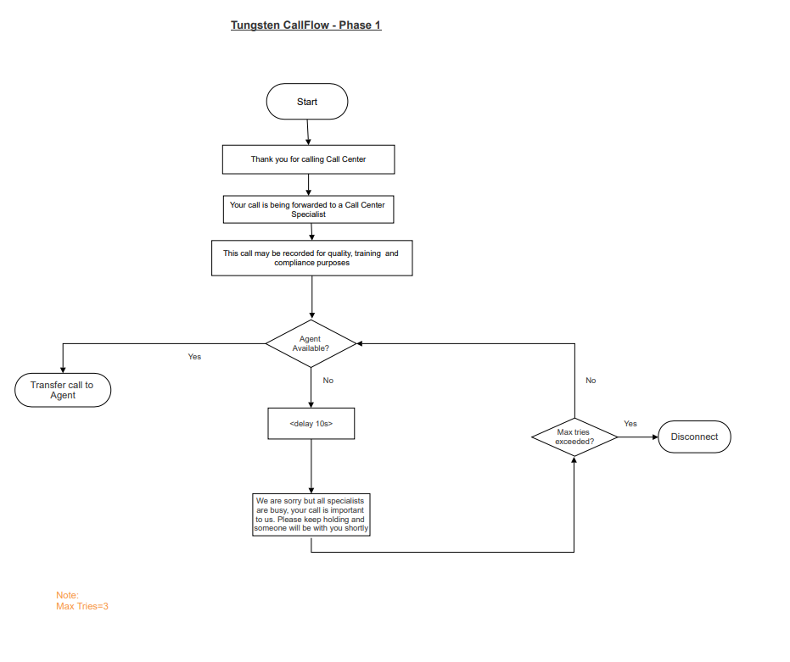

## Main IVR – Phase 2

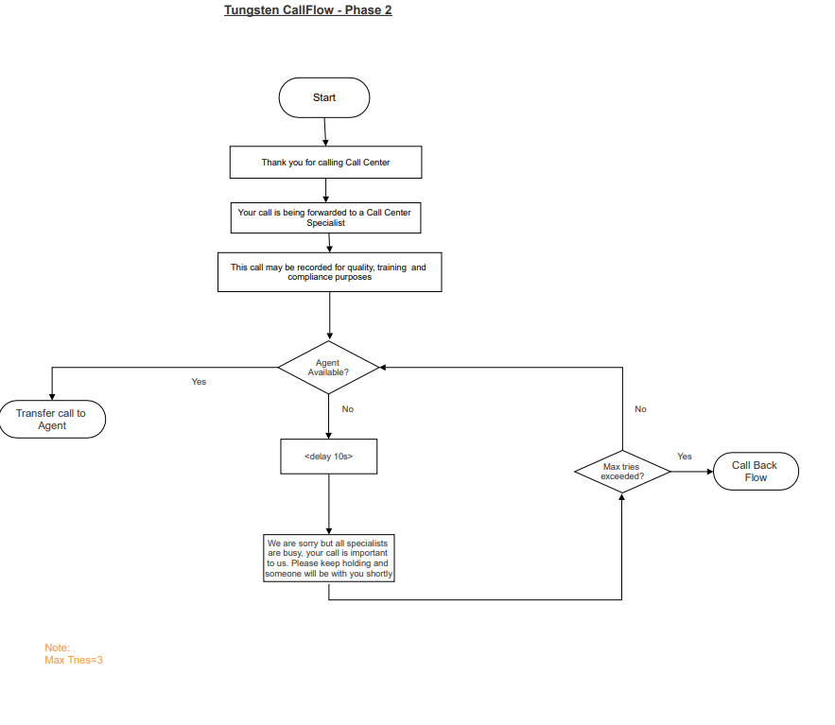

## Call Back Flow

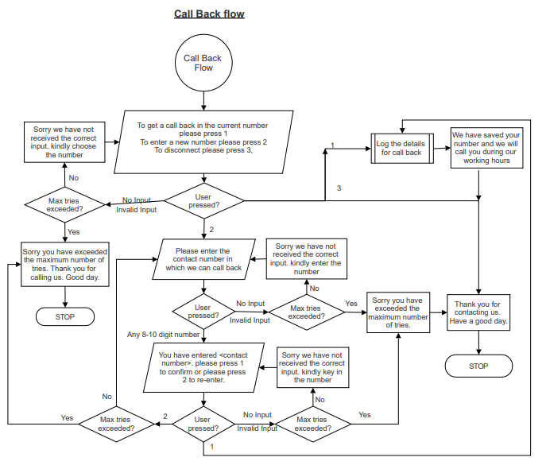

**Note:** Digital14 team to share the Arabic translated phrases for the approved English call flow[other than Main IVR phase 1- flow]

## Customer Feedback Application

At the end of every inbound call, if the customer is willing to provide feedback / survey, then the agents would transfer the call to the survey / feedback IVR application.

* Feedback questions would be provided for each survey type, and a different queue would be created accordingly.
* Below call flow explains the survey IVR application.



**Note:** After the welcome message, there will be an announcement in the IVR ‘We are conducting a survey, please press 1 if you are interested to participate, else please press 2’. Based on caller choice, Survey IVR will be invoked after Agent Disconnects the call.

### Feedback Admin Application Requirements

**Master values:** In this screen, the system admin will be able to define:

* The master list of questions, attributes and parameters.
* The master list of survey types that can be applicable. Example: Agent related survey, new product related survey, sales survey, customer happiness survey, etc.

**Maintain Survey Templates:** In this screen the system admin will be able to:

* Create the survey template – this is the screen in which the system admin will combine the parameters, attributes, questions to define the survey template. Also provide what is the minimum and maximum score that can be provided for each question, and provide the phrase file name that will be passed to IVR to play the phrase.
* Edit and view the already defined survey templates.
* Create a duplicate of an existing template by using the SAVE AS feature that will be available in the EDIT screen.

**Map Survey Templates to Survey types:** In this screen the system admin will be able to map any one of the created templates to the survey types that was defined in the ‘Master value’ screen.

**View Mapped Survey Template:** In this screen the system admin will be able to view the template that is mapped to the survey type. They can also replace the existing mapped template with a new template.

### Reporting Requirements

The following reports would be customized for the feedback application and is available as part of the admin module to activate the questions

* Individual Question Based statistics
* Summary reports on the customer responses with date ranges.

### Database Details

**Tablename: Feedback_Questions**

| **Fieldname** | **Type** | **Description** |
| --- | --- | --- |
| Survey name | Varchar(30) | The survey name |
| Question Number | Varchar(10) | Unique number of the feedback questions |
| Description | Varchar(200) | Detailed Description of the question |
| Primary Key | Foreign Key |  |

**Tablename: Feedback_Report**

| **Fieldname** | **Type** | **Description** |
| --- | --- | --- |
| Caller ID | Varchar(30) | Caller ID of the customer |
| Question Number | Varchar(10) | Unique number of the feedback questions |
| Description | Varchar(200) | Detailed Description of the question |
| Question Response | Varchar (30) | Response received from the customer |
| Date and Time | Datentime | Date and time of response |
| Primary Key | Foreign Key |  |

# CTI Requirements

The customer telephony integration requirements have two subsections such as agent screen pop and CRM screen.

## Agent Screen pop requirements

The below screenshot shows the working area in the Cisco finesse gadget where the Caller details will be displayed.

<todo: Screen shot for Agent Desktop to be added>

## CRM Screen

The below information collected inside the IVR would be presented to the agents as enterprise data on the Cisco Finesse application

* Caller ID (ANI)
* DNIS
* Language selected in the IVR (Arabic / English)

Once the call lands on the cisco agent desktop, the URL that is passed will be used to provide the pop up. The input parameter for the webservice invocation would be the caller ID.

For any emergency call, agent will manually select the emergency number from the phone book and initiate / transfer the call.

Below screenshot shows the system defined wrap up codes which will pop up once the call is completed. This will be displayed after the customer has disconnected the call.

<To do: To add the screen shot?

**Open points to be discussed in the CTI module.**

|  |  |
| --- | --- |
| **Clarification** | **Remarks / Answers** |
|  |  |
|  |  |
|  |  |
|  |  |

# Outbound Solution

## Preview Dialing

The agent will have option to view the customer details and then initiate the dialing of the customer number.

## Call back Request modules

When a customer calls in to a UCCX Queue and if at that time all available agents are busy and cannot take the call, then at a preset Timeout, a prompt is played. This is to ask the customer if they wishes for a call back. The customer can choose a call back option.

If the customer chooses call back option, then they will be prompted to enter the number in which they have to be called back. This number will be saved post confirmation from the customer and then the call will be disconnected.

The call back request collected from the customer are assigned as preview call back request campaign.

### Flow Diagram of Call back request module – IVR module



## Agent Assisted Outbound Requirements

The agent assisted outbound solution uses the preview dialing features of UCCX platform where the agents can see the details of the customer before initiating the dial out. The agents can cancel the call any time before dialing out.

# CUIC Reporting

# AQM Call Recording

**Call Recording and Quality Management:** The Call Recording and Quality Management component is a highly scalable voice and screen call recording and quality evaluation solution that supports agents, and supervisors at any location

**Call Recording:** Enables 100-percent call recording of agents or knowledge workers for compliance and transaction verification and includes on-demand recording and archiving; it also includes the search and play application to find and play back recordings

**Quality Management:** Provides audio call recording, quality evaluations, performance dashboard, and reports

Key features include:

• Voice recording

• Live voice monitoring

• Configurable quality evaluation forms including points and percentage-based scoring, sectionand question- level weighting, and unlimited number of sections and questions

• Up to 30 custom metadata fields, providing the ability to append important enterprise and customer data to recordings for easy search and retrieval

• The ability to control recording for manual start, pause, resume, and add metadata through Cisco Agent Desktop, Cisco Finesse gadget or Calabrio recording control browser or IP phone applications

• 100-percent voice recording for compliance and transaction verification

• The ability to evaluate, score, and report on the quality of customer interactions through any channel (chat, email, social media, etc.)

• Evaluation calibration capabilities, enabling contact center managers to benchmark evaluators

• Configurable and graphical reporting

• Role-based alerts to streamline evaluation workflows

• Advanced search capabilities that let you locate recorded calls quickly and easily

• The ability to export recorded files in .wav or Windows media formats

• Web 2.0-based framework and user interface

• Payment Card Industry (PCI) data security compliance

• System monitoring and notification utility that can alert through email or existing Simple Network Management Protocol (SNMP)-based network monitoring solutions; also, can match recording events to Call Detail Records (CDRs)

• A real-time recording status application that provides peace of mind that lines are recording

• Multiple recording storage locations that help ensure reliability if a server failover occurs

# 2Ring Dash Board and Wallboard

**Wallboard/ Dashboard:**

The real time dashboards are a software solution that empowers business users and supervisors to deliver information in real-time to every screen needed. A screen doesn't only mean large plasma screens in contact centres and breakrooms, the individual workstations of agents, supervisors, or even managers who are not part of the contact center.

The Dashboard supports Unlimited # of screens, all Standard browsers: Chrome, IE, Edge, Mozilla, Safari can be rendered on Tablets, mobile phones, Smart TV’

We understand that agents, supervisors, and managers have different expectations. To meet various team’s requirement,

the Dashboards includes a predefined set of key performance indicators (KPIs). The data are stored in the MS SQL server database, thus providing flexibility to customer to create / build your own KPIs.

In line with the business requirements provided, Cognicx is offering wallboard solution suite which can not only meet the current requirements but can also be scaled up for future enhancements and growth. The Dashboards & Wallboards (DW) provided the complete set Real-Time KPIs and grids that can be generated from a UCCX platform. It encompasses hundreds of metrics derived from Key Call Center parameters:.

* AGENTS (Contact Service Queues, Teams, Skills, and Sliding Interval)
* CALLS (Contact Service Queues, Applications and Sliding Interval)
* EMAILS (Contact Service Queues and Sliding Interval)
* TEXT (Contact Service Queues and Media Type)
* CHAT (Contact Service Queues, Team, Skills)
* AGENT STATES GRID (Skills, Contact Service Queues and Teams) è CSQs GRID (Sliding Interval and Contact Service Queues) etc.

# Pre-requisites

## VM server Pre-requisites

Supported Versions of VMware vSphere ESXi= 6.0, 6.5, 6.7 (For application fresh installs on ESXi 6.5 (VMFS5 only) and/or vCenter 6.5

|  |  |  |  |  |  |
| --- | --- | --- | --- | --- | --- |
| **#** | **Component** | **vCPU** | **vRAM** | **vDisk** | **vNIC** |
|  | Social Miner | 2 (4390 MHZ) | 8 GB | 2 * 80 GB | 1 |
|  | Standalone CUIC | 4 (3600 MHZ) | 16 GB | 200 GB | 1 |
|  | SQL or Oracle DB server to store/Update Finesse Gadget and Call back data in details | 4 (4390 MHZ) | 8 GB | 600 GB | 1 |
|  | 2 Ring Dashboard | 2 (4390 MHZ) | 8 GB | 300 GB | 1 |
|  | AQM Server | 2 (4390 MHZ) | 8 GB | 1 TB | 1 |

## General Prerequisites:

* NTP, DNS, AD, DHCP servers
* Access to Existing UCCX System
* Access to VM Client and other Cisco servers (UCCX, CUCM )
* Single point of contact from customer and 3rd party vendor
* Social Miner server should be in DMZ Zone
* Email Server access detail (Email ID, POP3 - Imap- server access details)
* Website developer vendor details for chat integration
* Customers website developer need to integrate chat in their Website using API document shared.
* Integrate the chat option in customer website is not our scope
* API details to send the wrap up code to CRM system or we will update the Wrap up reason code in DB.
* CRM URL API/format to pass the Caller ID and other Variable from finesse

.

# Project plan

Below is the snapshot of the project milestones.